DAY1 ASSIGNMENT 1

Basic Questions :

Q1. What are components of a computer ?

The components are

1. CPU
2. RAM/ROM
3. Input/output devices

Q2. Which CPU are you using in you laptop / mobile / PC ?

Laptop – Intel i5

Mobile – Octa core

Q3. What is size of RAM in your PC ?

8gb

Q4. Read Python documentation from

<https://docs.python.org/3/tutorial/index.html>

Q5. What are different implementations of Python ? Which implementation we are using ?

CPython, JPython, Python for .NET, IronPython, PyPy

We are using CPython

Q6. Who created python ? in which year ? where ?

Python was created by Guido van Rossum at the Centrum Wiskunde & Informatica (CWI) in the Netherlands in 1991.

Q7. What is PVM ?

PVM is python virtual machine which interprets and executes the byte code i.e .pyc file.

Q8. Python is platform independent or not ? Which platforms python can run ?

Python is platform independent . It can run on MacOs, Linux, Windows

Q9. Why python is platform independent ? What makes it platform independent ?

Python is platform independent because we can write it once and execute it anywhere. The code is first converted into .pyc file which can run on any machine. Thus we can execute that file anywhere.

Q10. WAP to Print "Hello IACSD" and write comment describing author of the program and date created

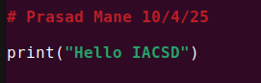

Q11. Find working of various functions (min 7) from math library of python which is provided as standard library.

https://docs.python.org/3/library/math.html

You can also try it yourself.

Ex.

import math

print(math.factorial(4))

print(math.sin(90))

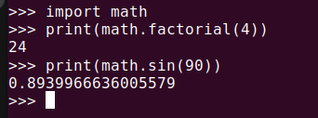

Q12. Open VSCode IDE and create a python program (.py file) to print Hello world!. Run the program and check the put on console.



Q13.WAP using VSCode IDE. Import math library and print the gcd, lcm of two numbers.

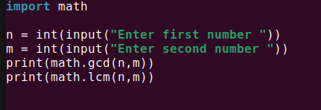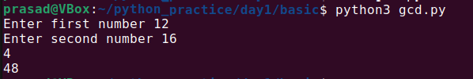

Q14. WAP using VSCode IDE. Use math library. Print number of options you have, when you are given 5 different characters and you need to select 3 of them without repeatitions. (find permutations)



Q15. WAP using VSCode IDE. Use math library. Print number of options you have to select 20 students out of 60 without repeatitions. ( Obviously here order doesn't matter, so find combinations)



Q16. WAP using VSCode IDE. Use math library. Try to find log of zero. Which error is given ?

Also try to find square root of any negative number. What error is give?

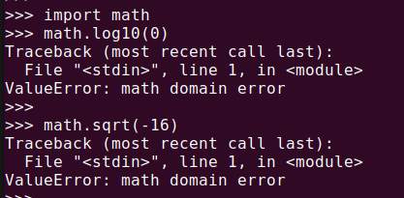

Q17. WAP to create a variable v1 and store any number. Find the square root of that number by using v1 in math.sqrt() function.

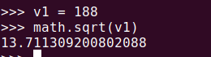

Q18. Why python is considered as slow compared to C, C++ ?

Refer : <https://stackoverflow.com/questions/3033329/why-are-python-programs-often-slower-than-the-equivalent-program-written-in-c-or>

Internally the reason that Python code executes more slowly is because code is interpreted at runtime instead of being compiled to native code at compile time.

Q19. Check where .pyc files are stored after you run the program for Q15.

.pyc files are stored in __pycache__ folder in the same directory where .py files are stored.